SKILLS FOR SUCCESS - CREATIVITY and INNOVATION

March 27, 12:00 - 4:00 PM EST

# Brainstorming Activity: When Creativity & Innovation Is Needed

| What are some situations where creativity & innovation might be valued? | What are some situations where creativity & innovation should NOT be a priority? |
| --- | --- |
| Definitely L&D: Creating creative and innovative learning solutions to ensure engagement and transfer of learning | Compliance policies and processes where there is a high risk to the organization: reputational risk or legal risk. |
| Team: creative problem solving | No situation should exclude creativity, for innovation, it would be right time, right place |
| More engaging ways to learn | Regulatory policies and procedures which are outside of the organization’s control. |
| To help streamline processes and create efficiencies. |  |
| looking for alternatives to overtime and planning how to tackle backlog work | Government processes |
| Communicating with people - don’t always rely on emails or social media. X is not a safe platform, yet big firms use it. |  |
| Creative/innovative tools & equip | If testing is missing, this can be more dangerous |
| Organization wide: New projects, initiatives, major changes |  |
|  |  |
| L&OD: Finding new ways to integrate training into the flow of work and other ways of streamlining processes. Sometimes it’s a process issue and not a training issue. | Same as above (regulation, policy, etc.) |
| Looking for new ways to develop training material. More engaging | When providing training on Policies |
| Creativity and innovation can definitely be valued when creating training and supporting training transfer. | Maybe a specific technical is used or if there is are constraints for developing training |
| In small business landscape right now - needing to redefine how services are offered | timecards. |
| As it relates to how AI is reshaping leadership, the way we work, the way we learn. In coaching conversations this seems to be coming up a lot in coaching conversations. |  |
| When the process to develop (and review) training materials is excessively long and tedious and it does not help improve training outcomes, we can use creativity and innovation to find different ways to make the process more efficient. | When training content needs to adhere to industry regulations and guidelines, it’s hard to prioritize creativity and innovation. |
| To boost productivity |  |
|  |  |

# Breakout Activity: Overcoming Organizational Barriers To Creativity & Innovation

| What organizational structures get in the way? | How could you overcome these barriers? |
| --- | --- |
| Money, budget | Strong business case for allocation - leadership buy in, showing evidence of benefits |
| Resources |  |
| Regulatory compliances |  |
| Policy and processes create hurdles. Resistant to change within the policy and processes. | Look at the programs and funding you already have.  Use a thinking exercise and ask ‘how can we make the policy even worse?’, by thinking along that line, we can identify the problem/barrier within the policy or process. |
| Hierarchical structure of the team can slow down creativity and innovation. It can instill fear of the unknown within the team, because they don’t know how leadership will react to the innovative ideas. | Create a two-way street communication between the team members and the executive team. Having leadership endorsement will also help. |
| Organizational Cultural | Looking at organization mission and values |
| Too many layers of approval required | Set expectations of what you are specifically asking with endorsement. E.g. signature, approval, feedback, etc. |
| Org. structure and how teams report to one another. You may not be able to reach the person who would collab best with you. | Willingness to connect people in different parts of the organization. |
| Financial/budget barriers | Look into funding opportunities outside the org. |
| Time & focus on productivity | Implementing creativity in part of the work flow. Coaching creativity. |
| Know your audience | Address their needs to visualize the impact of the ‘creativity and innovation” brought forth |
| Time constraints. Ideas may flow, but folks may not have the time to roll with it. | Establish a committee and allot a specific time and schedule as a minimum (once a week/month, etc) |
| Lack of Knowledge Transfer | Document ideas, ROI, communication plan, sustainability plan and point of contact |
|  |  |
|  |  |
|  |  |
|  |  |

# 

# Breakout Activity: Creativity & Innovation Learning Interventions And Supports

## 

* Design a specific learning activity you would use to develop individuals
* Identify what other support is needed by :​
  + Managers
  + Leaders​
  + Organization

|  |  |
| --- | --- |
| Individual | Have participants tackle one simple task with very simple materials ie; using newspapers and tape, or box of lego, etc. to build a simple structure (table) and it will only highlight the different creative and innovative styles from each participant. All the results will be different even though the materials are the same. |
| Managers | Debrief with the individuals regarding what ideas worked, what didn’t, what could be improved upon. When multiple groups are involved, work with open/non-judgemental discussion about components that worked and shared successes.  Effectively communicate with individuals to foster that they lean into creativity without judgement. Openly discuss the “how” people came up with their ideas. |
| Leaders | Ensure and endorse that time is allotted for this kind of team-building activities to foster collaboration across teams. |
| Org | Reward system for participation and “winners” of the task/assignment (ie; strongest structure, tallest, stood the longest”) are awarded something like a coffee gift card. Encourage ongoing participation in the activities. Encourage participation on suggestion of future/ongoing team building activities and friendly competition (suggestion box - anonymous suggestion/participation). Suggestions could be within a sort of agenda/connection to organization’s demands/projects/etc. |

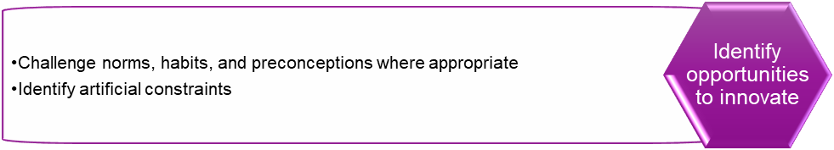

* Design a specific learning activity you would use to develop individuals
* Identify what other support is needed by :​
  + Managers
  + Leaders​
  + Organization

|  |  |
| --- | --- |
| Individual | Intentional practice. What does creativity and innovation look like? Set parameters and definitions. Asking challenging questions.  Learning activity: How to challenge. Run through a case study and practice task (low-stakes). Then, meet with your manager to talk about your approach to the learning activity. This builds confidence and accountability in the skill development. |
| Managers | Communicate with teams: this is our new approach. Here is how we do it - the steps. A guide to show your work - standard template to use. Managers meet with learners 1-1 to coach on the skill development. |
| Leaders | Asking for ways to demonstrate innovation. Here’s the new approach we can use to start small and build from there. We are going to challenge what we are developing/producing. The process we will go through is team challenges. |
| Org | Part of 2025 strategy - we want to foster creativity and innovation. |

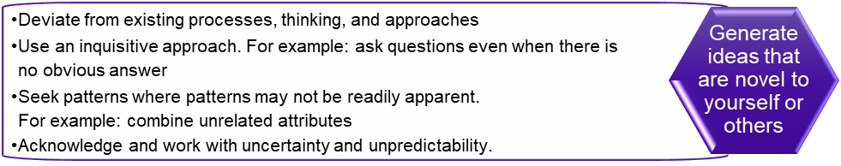

* Design a specific learning activity you would use to develop individuals
* Identify what other support is needed by :​
  + Managers
  + Leaders​
  + Organization

|  |  |
| --- | --- |
| Individual | **“Escape like” game - group activity**   * In person activity not virtual * Scenario-based activity without guidelines but with time limit to accomplish the activity. Example: Device for retail stores to use to close a transaction with a customer. 1 device for 2-3 people. They need to figure out how to use it and complete the same retail scenario (e.g. returning merchandise)   + Repeat the activity for other retail scenarios * The activity depends on the company/organizational needs * Series of puzzles, clues, riddles * Asking questions * Inquisitive approach * Allows the creative and innovative approaches of the individuals by trying to figure out how the device works to solve the scenario that has been given to them. * Permission to fail * Feedback from individuals - What works? What needs improving? |
| Managers | * Buy-in * Paid time to allow the activity to happen * Set-up/organizing * Ensure that all the equipment needed is there/advocate for the activity * Open mind to creative & innovative ideas * Permission to fail * Demos all the correct processes for all different scenarios after the activity. |
| Leaders | * Buy-in * Open mind Open mind to creative & innovative ideas * Permission to fail * Provide devices in a sandbox environment |
| Org | * Buy-in * Open mind to creative & innovative ideas * Permission to fail |

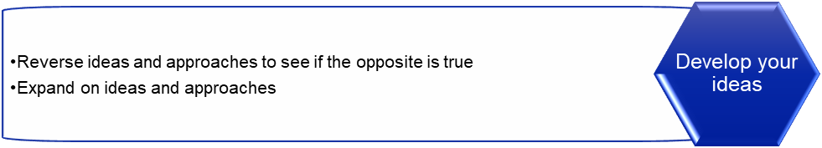

* Design a specific learning activity you would use to develop individuals
* Identify what other support is needed by :​
  + Managers
  + Leaders​
  + Organization

|  |  |
| --- | --- |
| Individual | **Self-Reflection**: Managing distractions - What are you experiencing? How are you struggling to manage distractions?  **Table Group Activity**  Part 1: Participants share their self-reflections on “**Managing distractions**” and have the team do a reverse brainstorm of a problem to see how to make the problem worse.  Identify what the impact will be if they don’t solve the problem?  If we don’t think differently, then we will keep getting the same results (Aristotle’s definition of insanity).  Part 2: Share key-takeaways - What will you do differently to manage distractions? |
| Managers | Let team members know that it’s okay to allocate time to do focused project work.  Agreed-upon work norms like you don’t have to respond to email outside of your working hours and that they would flag urgent emails if necessary. |
| Leaders | Foster a creative culture where people can be innovative or can think differently.  Walk the talk - team members can see that leaders practice the innovative ideas that they support.  Be open to team members making mistakes as they practice and learn.  Deliberately set up time to meet and hear ideas from their team members. |
| Org | Must be included as a value in the organization  Celebrated in the organization to show that they value it  Allocate time and budget to support these activities |

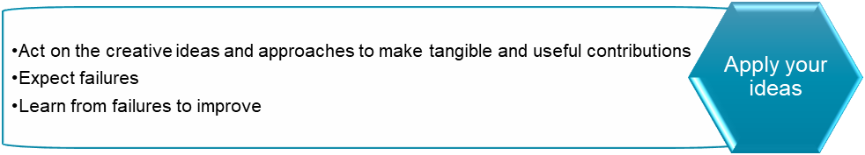

* Design a specific learning activity you would use to develop individuals
* Identify what other support is needed by :​
  + Managers
  + Leaders​
  + Organization

|  |  |
| --- | --- |
| Individual | Assumption - they have an idea and know how to apply it  Learning Activity - De Bono’s Six Thinking Hats - Blue hat - look at logistics - what resources or tangible things needed for fruition. Red hat - look at emotions - anticipate barriers - emotions and thinking. Explore fear. Green - use the creativity hat to create the solution. White Hat - seek facts & figures to support plan. Black is the opposite - what didn’t work with other approaches - what could get in the way of it not working (Black hat will help us to anticipate failures and learning from failures).Yellow hat - how can we get some ways to get around the hindrances.  To help build capacity for failure - Resilience. Adaptability.  How do we see failures - reframe to Lessons Learned.  When receiving feedback - examples of how innovation has occurred and how it went through ongoing iteration and changes. Show how it is ok to fail - provides a different perspective.  Also adopting/building a mindset for innovation (Thomas Edison - 1000 ones that did not work). Don’t take it personally - even if it is a failure - it’s part of the process.  Mindset -  Beginners mindset - expect that something won’t got to plan  Closest to the Hole - Activity for Fundraisers |
| Managers | * Support - guidance and communications - since learning from failure - what is the lesson, and how can we improve?\ * Feedback is essential. Build in some 1-1 time to check in and discuss how application is going. . * Share what doors need to be opened - are there any silos? * Coaching approach to build capacity of team members * Mentoring and connection with others in the organizations that they an learn from * Also offer resources from corporate university/leadership program |
| Leaders | * Have leadership sponsorship - leader assigned to it - they could come to launch plan and be involved. \ * Create key communications - “From the Desk of…” * Leaders create an environment of trust and safety - identifying and developing new ideas. * They provide encouragement and an environment where you can talk about the ideas and failures. Help to reorganize thoughts. * Encouraging an innovation mindset - it’s ok to go outside the line * Can be instrumental in paving way for global system/business process for cross-pollination - Innovation Hub/Intranet (Document knowledge transfer and capture lessons learned - how did you apply it? What lessons learned?) |
| Org | * Encourage retrospectives - learning, * Tollgate report out - do differently - lessons learned to a report out - this is how we have mitigated it so it is done all along the process. * Knowledge management - capturing institutional knowledge and sharing Database. |

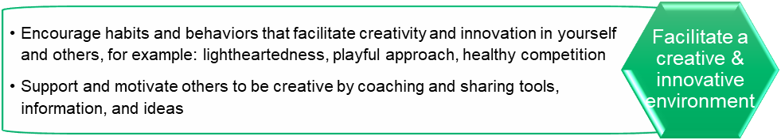

* Design a specific learning activity you would use to develop individuals
* Identify what other support is needed by :​
  + Managers
  + Leaders​
  + Organization

|  |  |
| --- | --- |
| Individual | The Marshmallow Challenge is a fun and insightful team-building activity that tests creativity, collaboration, and problem-solving skills. Here’s how it works:  Objective: Teams are tasked with building the tallest free-standing structure possible in a set amount of time, typically 18 minutes.  Materials: Each team gets 20 sticks of spaghetti, 1 yard of tape, 1 yard of string, and 1 marshmallow.  Rule: The marshmallow must sit on top of the structure, and it has to remain stable without support.  The activity emphasizes the importance of prototyping, iteration, and learning from failure. Many teams fail initially because they spend too much time planning and not enough time testing. It’s a great way to demonstrate that collaboration, trying things out, and adaptability lead to success.  Debrief: After the challenge, lead a group discussion:  Measure and Discuss  When the timer ends:  Which structure is tallest  How did you decide on the approach?  If any structures collapse, discuss why.  The activity is easy to organize and offers a great platform for learning through fun. Apply the thinking as a transferable skill - what problems can be solved in a unique way? |
| Managers | Encourage the employees to complete the activity by providing them with the time and support.  Communication with them the value of this activity  Encourage the employees to participate actively  Provide a safe environment for the employees without judgment  Provide opportunities to the employees to apply what they learned in their today to day tasks. |
| Leaders | Leader Buy in  Providing Practice Based Skills  Transfer to knowledge How can we solve problems in day to day based on learning activities |
| Org | Provide an environment that supports creativity and innovation  Align the training with the organizational goal  Provide a learning culture to support this type of activity |

